

**Process of feeding Dynamic data into DNIF A10 Container Using Postman Application**

**About Postman :** Postman is a application for interacting with HTTP APIs. It presents you with a friendly GUI for constructing requests and reading responses.

**HTTP VERBS generally used in POSTMAN**  
**GET** : Read a specific resource (by an identifier) or a collection of resources.  
**HEAD** : Works same as GET, just returns the header.  
**PUT**: Update a specific resource (by an identifier) or a collection of resources. Can also be used to create a specific resource if the resource identifier is known before-hand.  
**DELETE** : Remove/delete a specific resource by an identifier.  
**POST**: Create a new resource. Also a catch-all verb for operations that don't fit into the other categories.

**Steps carried out to feed data into DNIF Console using Postman Application:**

**Step 1 : Access the DNIF Container via SSH on a custom SSH Port i.e. 826**

1. Login into the DNIF Container using the Host Machine and ssh using the root user to the mapped SSH Port using the following command.

**$ssh root@localhost -p 826**

1. **Enter the required password credentials as mentioned in** <https://dnif.it/docs/guides/tutorials/access-dnif-container-via-ssh.html> in order to access the DNIF Container. Following bash prompt should be visible in the terminal:

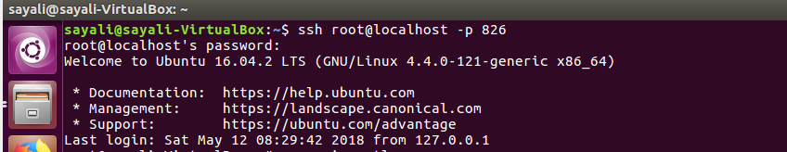

1. **Once logged into the terminal , check for the currently running services using the “supervisorctl” command as shown below:**

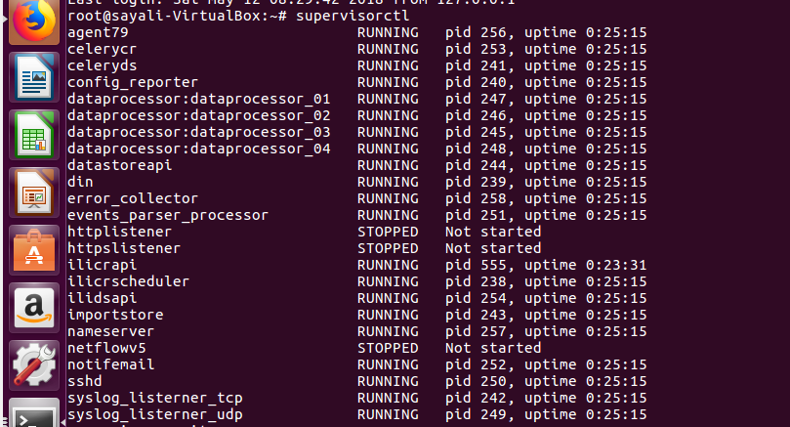

1. In order to Post request using Postman check for the following two services to be in RUNNING Mode.
2. **httplistener** : Running on Port Number : **9234** – Should be in RUNNING State
3. **httpslistener**: Running on Port Number : **9236**—Should be in RUNNING State
4. In order to start the required services as shown in the screenshot below, use the following commands:

**supervisorctl > start httplistener**

**supervisorctl > start httpslistener**

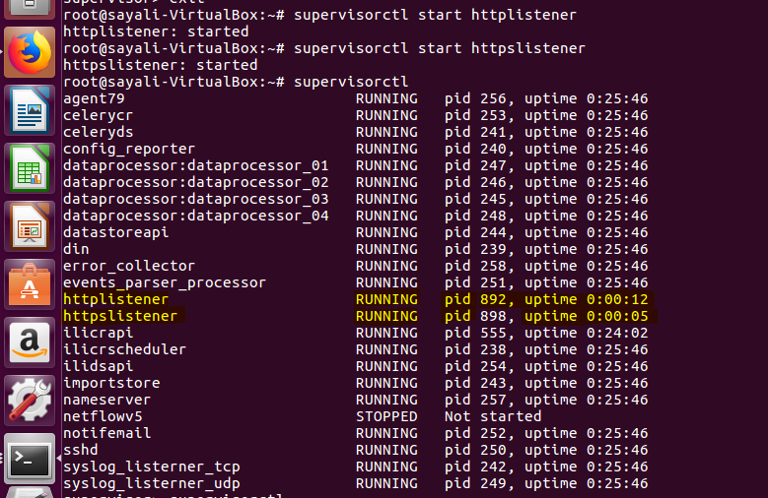

**Step 2: Download the Postman API Development Environment from the given link below:**

<https://www.getpostman.com/>

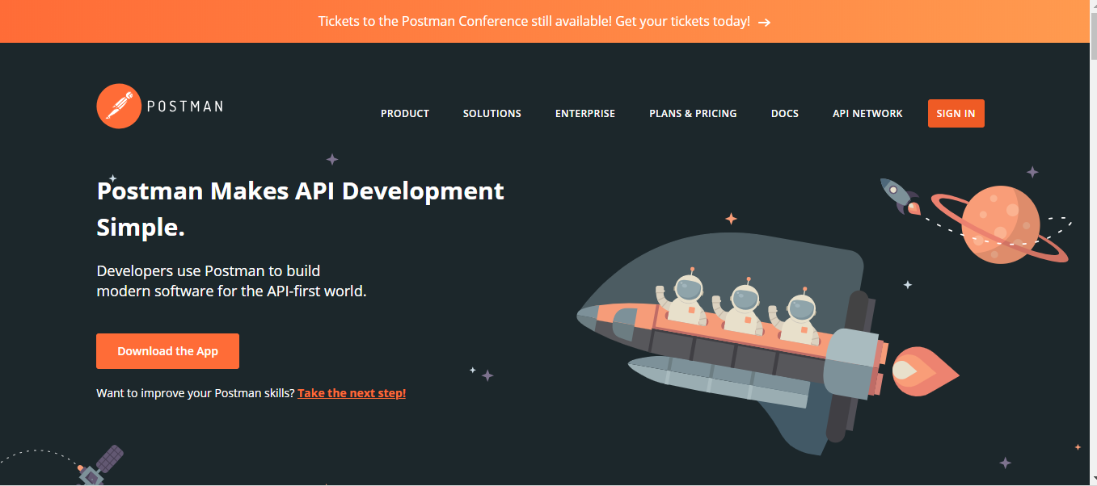

**Step 3: Once downloaded, open the Postman Desktop application:**

1. **Under Create New Tab, click on Create a Request in order to create a basic Request:**

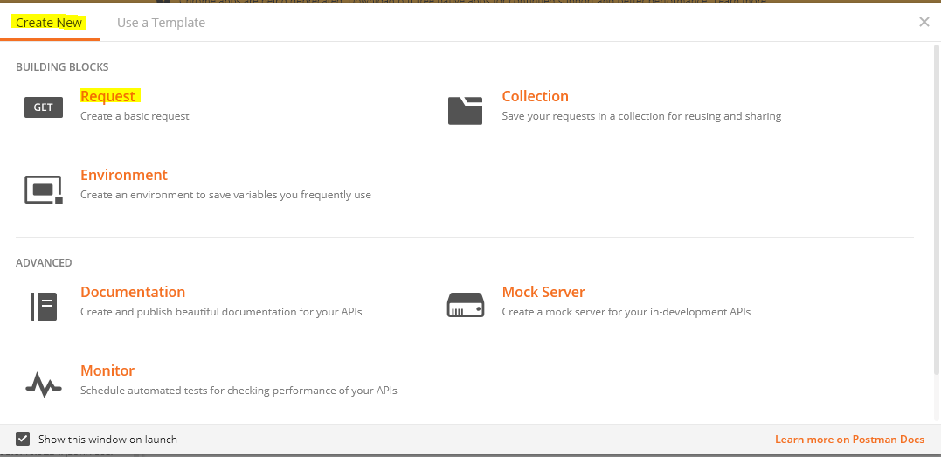

1. **Enter the following Details in Save Request Window:**
2. Request Name

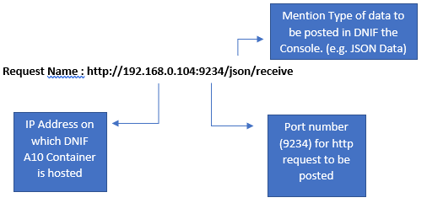

1. Request Description : Optional
2. Select Collection : Postman-Echo
3. Click on” Save to Postman Echo” button

Save Request :

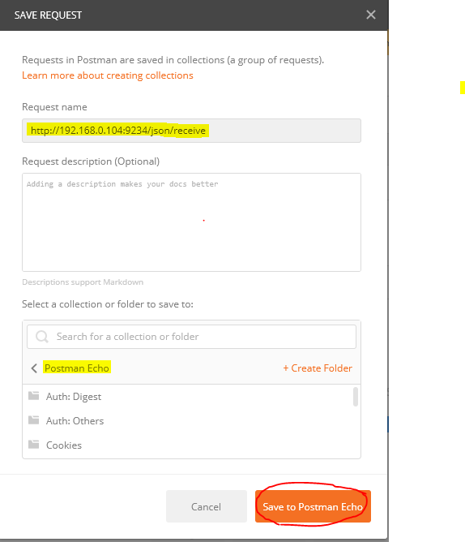

**Step 4: Following Window is visible to the user:**

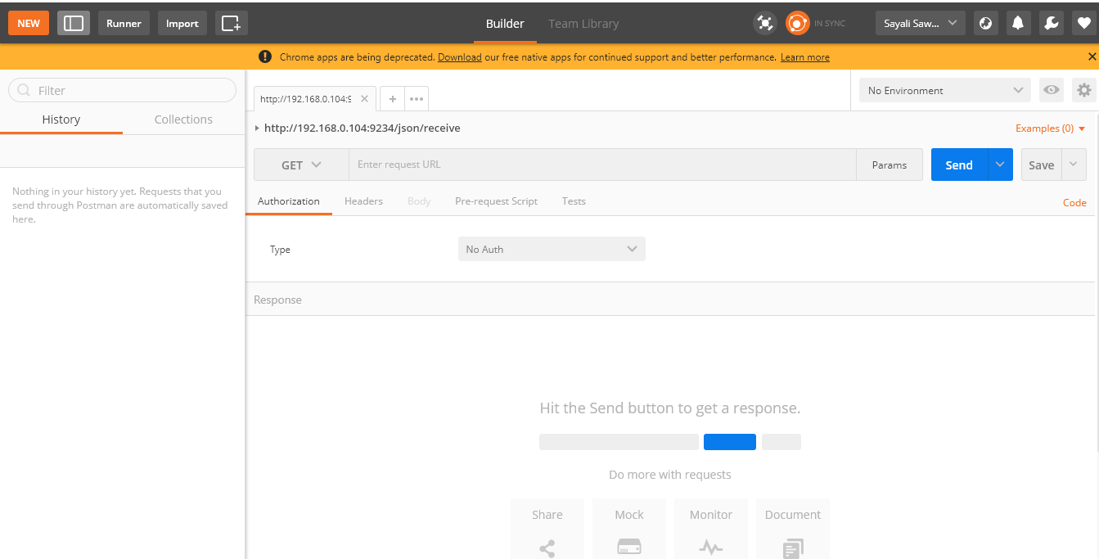

1. **In order to POST JSON Data, Select POST option beside the mentioned URL Name:** [**http://192.168.0.104:9234/json/receive**](http://192.168.0.104:9234/json/receive)

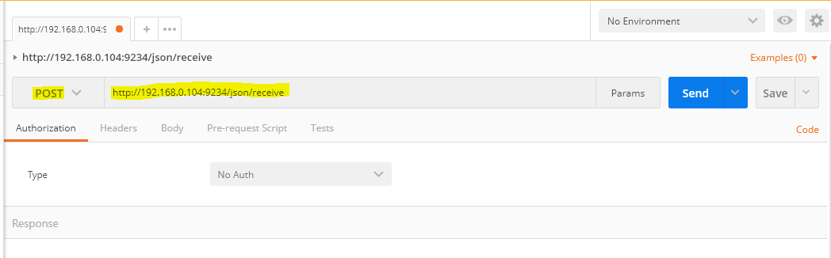

1. Under Body Tab, Select on “**raw**” radio button and select **JSON(application/json)** as shown below:

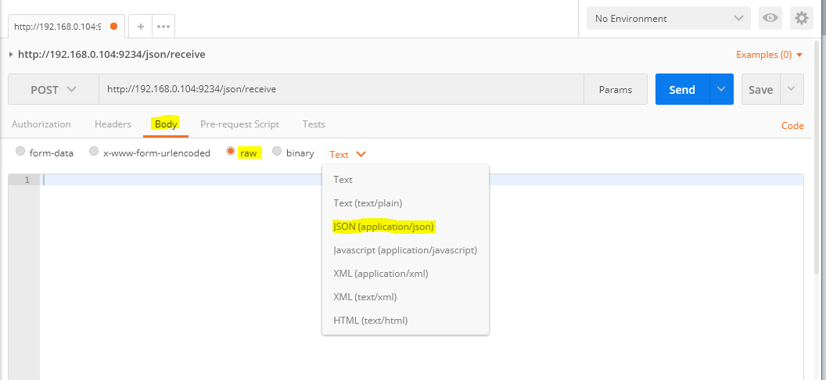

1. After selecting **JSON(application/json),** following details should be visible under **Header** Tab.

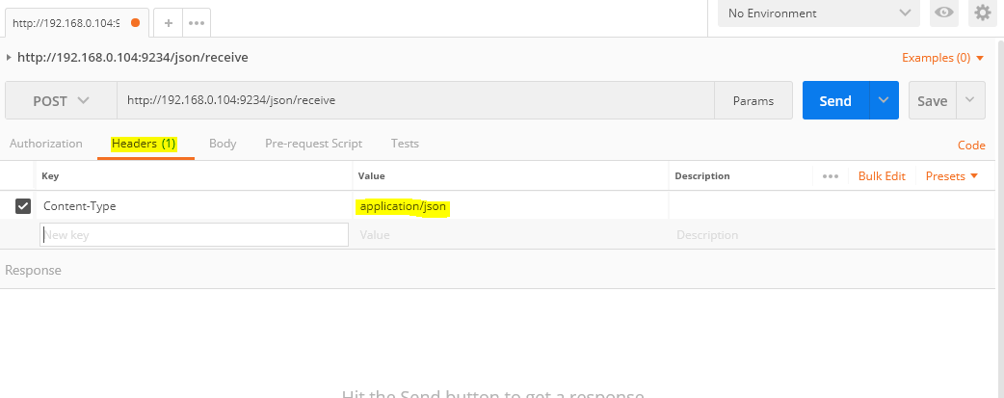

1. Under the **Body** Tab , include the JSON data to be posted to the DNIF Console in the following format (key : value – dictionary format) :

[

{“field1”: “data1”} ,

{“field2:”data2”},

.

.

.

{“field n”:”data n”}

]

Refer the below screenshot to view the JSON data to be posted in the valid format.

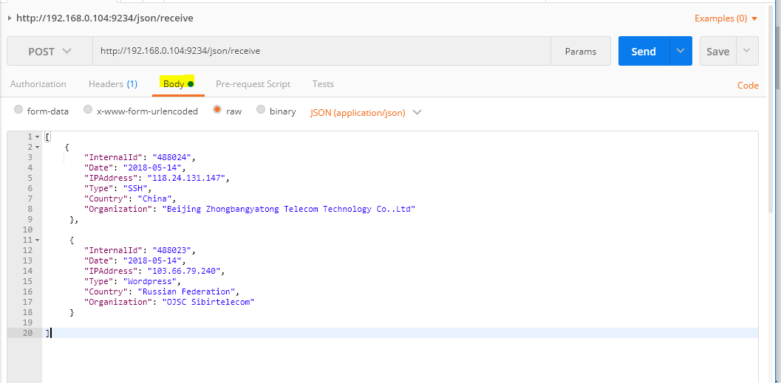

1. Click on **Send Button**

The Request should be Posted and under **Header** Tab : Status of the Response should be “**added”** for the posted JSON data as shown below:

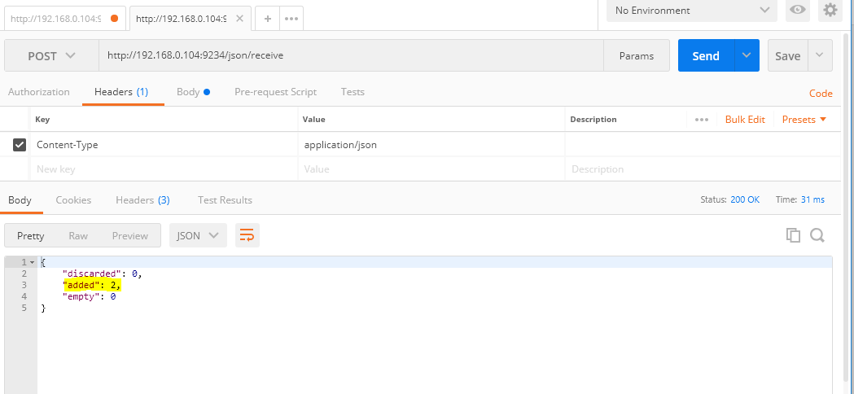

Step 5: Login into DNIF Console using <https://go.dnif.it/>

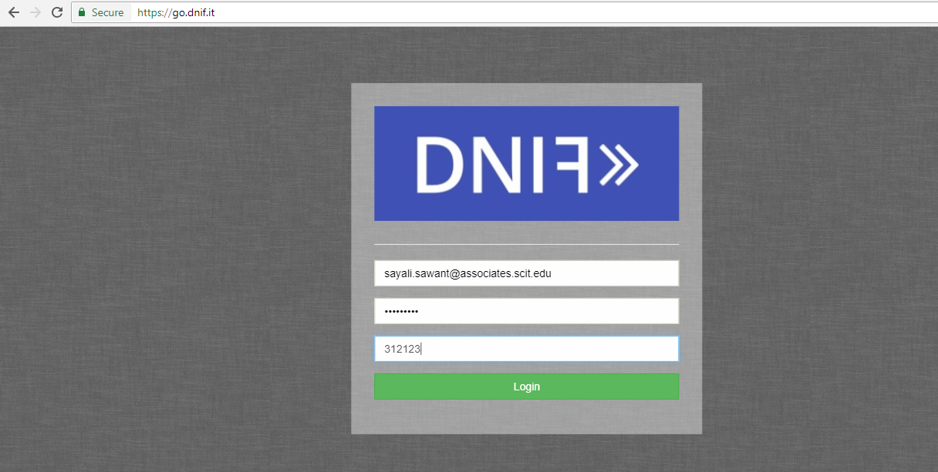

1. DNIF Console should be visible as follows :

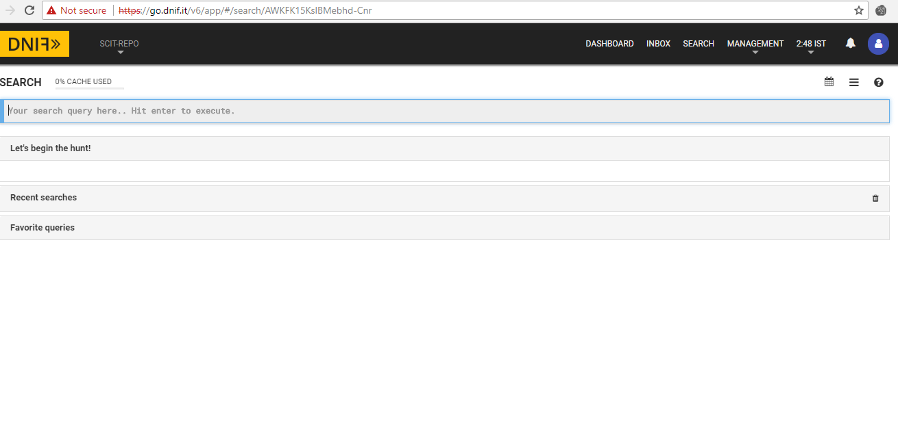

Posted Data should appear on the DNIF Console by using the following query under Search Tab :

**_fetch * from event limit 100**

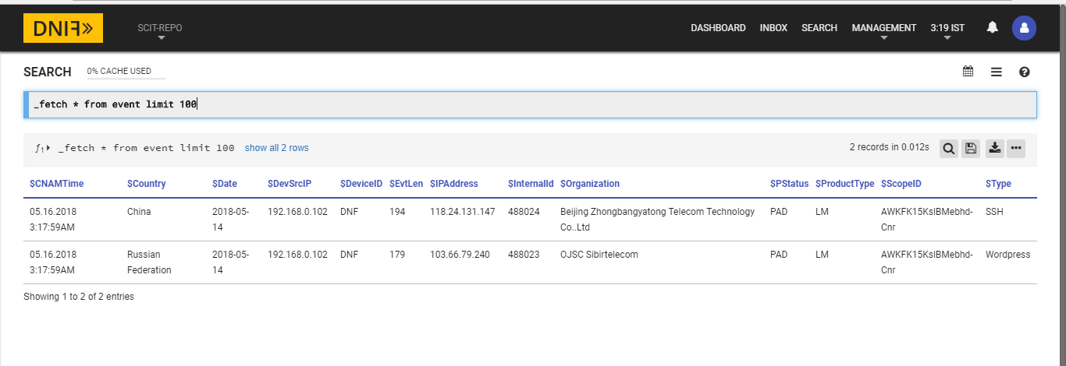

**Entire Dataset:**

